DOSSIER PROJECT

Name: Luke Costelloe

Address: 200 Rue de Provence, La Saulce, 05110

Developpeur-se Web et Web Mobile Niveau III

SHOPPING LIST AVEC REACT

SUMMARY

After having spent months learning HTML, CSS and Javascript, along with database management using PHP and MySQL, I began my stage with a small web development company. The development stack used by the company was known as MERN, that is MongoDB, Express, React and Node.js. The majority of my stage was composed primarily with learning React.
For my final project I decided I would put my new skills to the test, and also push myself a bit further by implementing this development stack into my project.
I wanted to create something useful and fun, which required both a front and back end element. I decided on a shopping list, first of all because it is a popular project among young React developers, so I was sure to find a very helpful community online for developing my own version, and two because I want to have my own personal shopping application for personal use. I would consider it a large acheivement not only to have created an impressive project for my qualification in web development, but also to have come out the other side with something I can use in my day to day life. After all, this is the reason I approached web development in the first place, to create websites and applications to make life easier for everyone.

INTRODUCTION

I began my training in web development with Simplon in May 2021. I was searching for a career change that would be challenging, and would allow me to practice my intellectual and creative skillset. The idea of using logic and mathematics to design something was extremely exciting.

After working on various briefs throughout the course, the final project arrived and I was faced with developing a full application alone.

Liste des competences couvertes par le projet

Activité-type 1
Développer la partie front-end d’une application web ou web mobile en intégrant les
recommandations de sécurité.

1. Maquetter une application.
Le design original du site a été créé à l'aide de Figma
2. Réaliser une interface utilisateur web statique et adaptable.
CSS was used to create a website that is responsive to mobile and desktop devices
3. Développer une interface utilisateur web dynamique.
React was used to develop the front end, with Express and Node.js being used to communicate with the back end

4.Réaliser une interface utilisateur avec une solution de gestion de contenu ou ecommerce.
The page contains a login system with the ability to manage data by connectin to MongoDB

Activité-type 2
Développer la partie back-end d’une application web ou web mobile en intégrant les
recommandations de sécurité

Compétences:

1. Créer une base de données
The project uses MongoDb for storing data, this is acheived with Express and Node.js allowing communcation with the React application.
2. Développer les composants d’accès aux données
Axios was used in the React application, as well as Express. The combination of these techs allows a CRUD within the app.
3. Développer la partie back-end d’une application Web ou Web Mobile.
Development of the backend is acheived with Express, mongoose and Node.js.
4. Elaborer et mettre en oeuvre des composants dans une application de gestion de
contenu ou e-commerce.
Development of an article type component (events) with functionalities
edits, displays and shares.

CAHIER DES CHARGES

React Shopping List

Objectives of the site

The site allows users to create a shopping list, which can be carried and used on a mobile device.
The site must be easy to use and personalise for each user, who can create a unique login account. It will allow them to organise items they need to purchase in an easy to read list, that is customisable. The lists can be saved and stored in the user dashboard.

Who is the site for?

The site is for anyone who wishes to be more organised in their shopping, while also being eco friendly. The sites ease of use and simplicity is designed for anyone, it is not complex to use.

Content of the site

The site consists of a login page and an account creation page. Once the user has logged in there will be a main list page containing an editable list, and a dashboard page which will give the user access to more personal information.

Site tree structure

Login Page (username and password fields, submit button, link to create account)
Create Account Page (username, password, confirm password, submit, link to login)
List page (input fields for item and number, list, button for edit, button for delete)

TECHNICAL SPECIFICATIONS OF THE PROJECT

After working on React during my stage, I decided this would be a great opportunity to further develop my front end skills with this technology. Connecting a back would be a bit more complicated, but I decided to go with a MERN stack, which is a popular stack in the industry.

THE SERVERS
For the majority of development during the project. Localhost was used as a server. Localhost is always located on the users own computer, it is basically the computer communicating with itself when using localhost.

When it came time for deployment I used a domain name purchased using namecheap.com and hosted on netlify. Netlify is a free hosting service that allows for continuous deployment, which means you can link a github repo to your domain, and any changes or commits made to the repo will automatically be made on the live website aswell.

THE PROGRAMMING LANGUAGES
Javascript: With a basic understanding of Javascript, React can be used. It is essentially a Javascript library so much of the same logic is used. Variables are defined, as well as functions, conditionals and loops.

JSX: Javascript XML is a form of markup that allows us to write HTML in React by converting HTML tags into React elements. This is an extension to Javascript based on ES6. When it comes time to compile, it is translated through Babel, which compiles the code in Javascript ES5, which is compatible on all browsers.

CSS: Cascading Style Sheet was used for styling all elements of the project. CSS formats the document contents layout, colours, fonts etc. It defines how we “see” the content of the web page or application. CSS has many frameworks available to make development faster including Bootstrap, Tailwind CSS and Foundation to name a few.

VERSION CONTROL

- The frameworks
Express is a web framework for Node.js which helps to create server-side web applications faster.

- A package and dependancy manager

I used npm (node package manager) as my package manager. It can be used with Node.js directly in the VS code terminal. All npm packages are define in files called package.json. The content of these packags is written in JSON. At least two fields must be present for each file: name and version.

Npm can also manage dependancies. Npm can install all dependancies, they are also defined in package.json.

6.Bundles

- Javacript libraries
React is the javascript library used for this project. React allows for the creation of re-usable components for development. This prevents unrequired repetition of code and leads to an overall cleaner codebase.
Other:
Cors
Mongoose
MongoDB

Achievements and code snippets, Acheivements and code snippets

1. Using Regex, Axios and useState to create an account

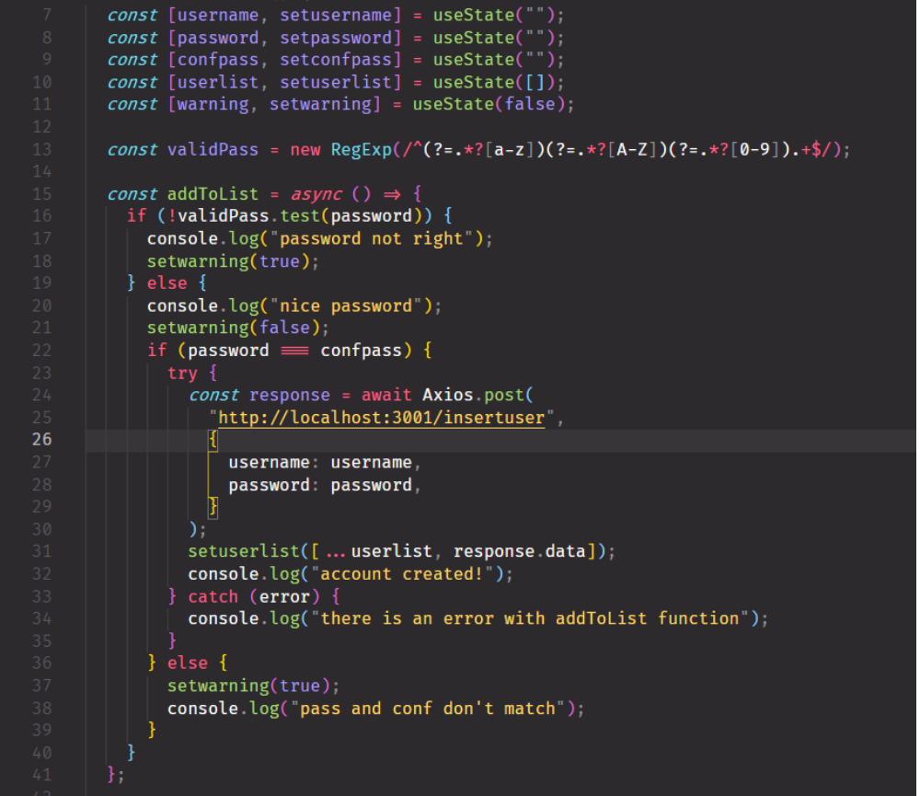

Here is the function used to create an account, and register it within the database for users. A regex is created to require lowercase, capital and numbers in the password(13). This is then tested to be true in the function. If there is an error a useState warning will be set to be displayed client side (18) if the test passes, it moves on to the next phase.

If the password and the password and confirmation match, an Axios.post is made sending both the username and password variable to the “/insertuser” endpoint. The user is also added to the userlist state, which can then be used for the login page to compare existing users (line 31)

There is a catch error if for any reason the Axios request is unsuccessful, a console.log will be given. Also there is an else case if the password and password confirmation don't match

- An example of XML
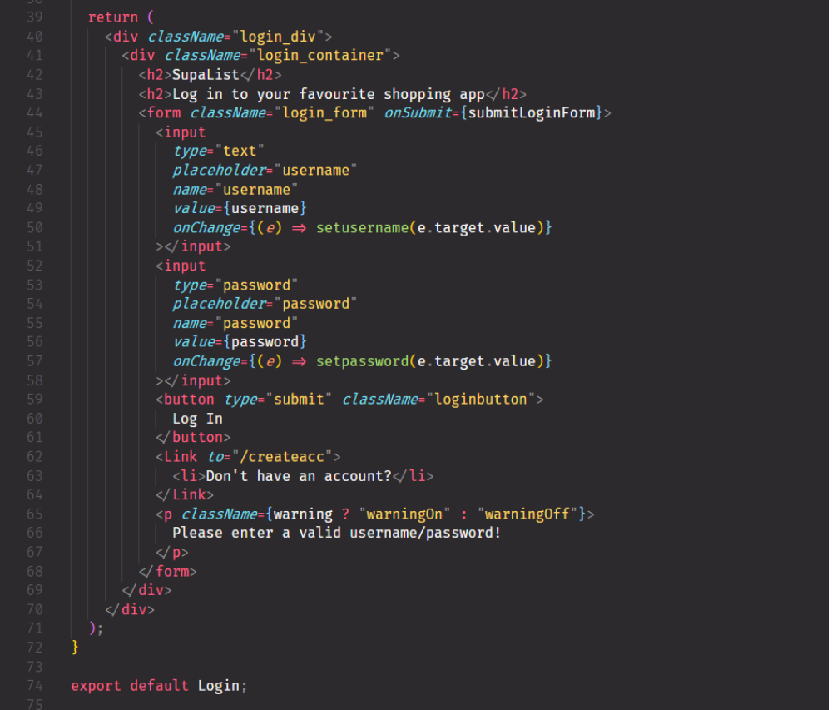
Here is an example of XML code for the Login page. At the end of our component function we have a return statement. In these parentheses is our XML code, which looks very similar to HMTL. This is the code that will be rendered to the page from the function component. We have familiar elements like div, h2, form and button tags, but XML allows us to embed Javascript logic also.

For example a function is being assigned to the form submission in variable parentheses (line 44). For the input values (line 50 and line 57) we can see functions being created on the onChange attribute. This is called an inline function. For example the function is taking the value of the form change and setting a state “username” (line 50) to this value.

3.Using Axios to read and insert

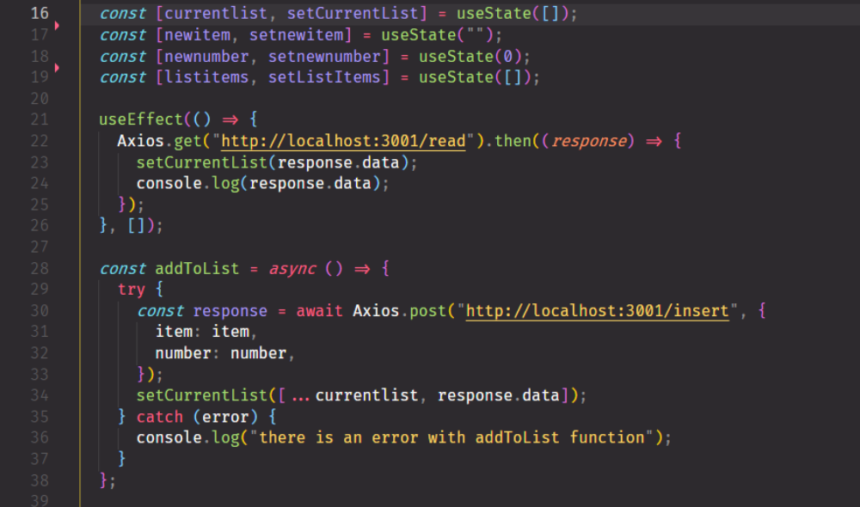

Here we can see a number of use cases for Axios. In line 23 useEffect is used along with Axios. UseEffect allows for a function to be called immediately upon rendering the page. Axios.get pointed at the endpoint “/read” gathers the items that are currenlty registered in the collection, and the useState function is used to enter these values into a state to be displayed client side (line 25)

An async/await function can be seen starting at line 30 to add items to the list. An await is called by the Axios request, telling the code to continue only when the value from the Axios request has been gathered. Then the values are added to the current list state (line 36). A catch is used for errors, if for any reason the Axios request was unsuccessful, there is a console.log notifying the error.

4. example of a Schema

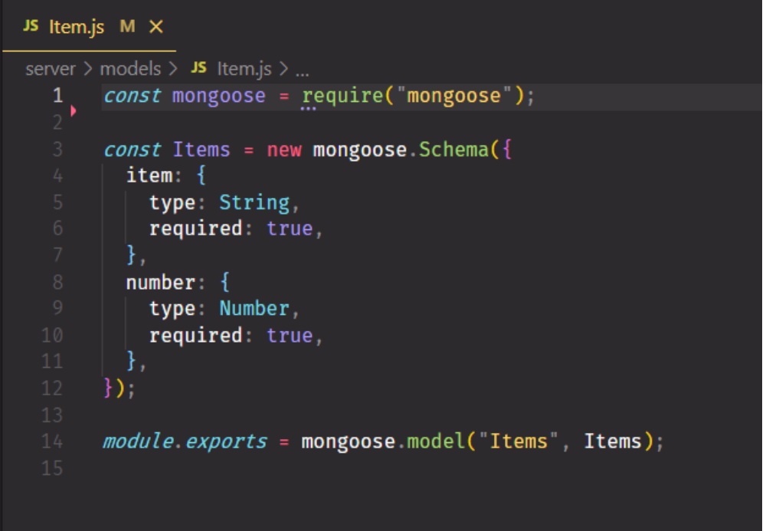
A schema is essentially a database structure described in formal language. It defines the terms in which information in the database will be stored. For example this item schema is declaring that items insert client side will be registered server side with this format, each item will have an item name and number. (eg. Bread, 1). Mongoose allows for object modelling and schema creation. Although with MongoDB it is technically not required to create a schema beforehand, but I chose to do it nonetheless to allow ease of reading in the codebase. Finally we export the schema to be used in our server side code, defining terms for our CRUD.

Presentation d'un jeu d'essai, presentation of a test game

Veille sur les vulnerabilities de securite liees au projet, monitoring of security vulnerabilities related to the project

Description d'une situation de recherche, description of a research situation

Traduction d'un extrait de site anglophone, translation of an English speaking site extract

Because English is my first language, I did not have any difficulties translating English speaking sites during my coding journey. The majority of resources for programming are available in English, so I am lucky in this regard. I have nonetheless included an extract from stack overflow regarding inserting images into React projects. The process is slightly different from the normal method with HTML, and I often found myself returning to this question time after time.

https://stackoverflow.com/questions/39999367/how-do-i-reference-a-local-image-in-react
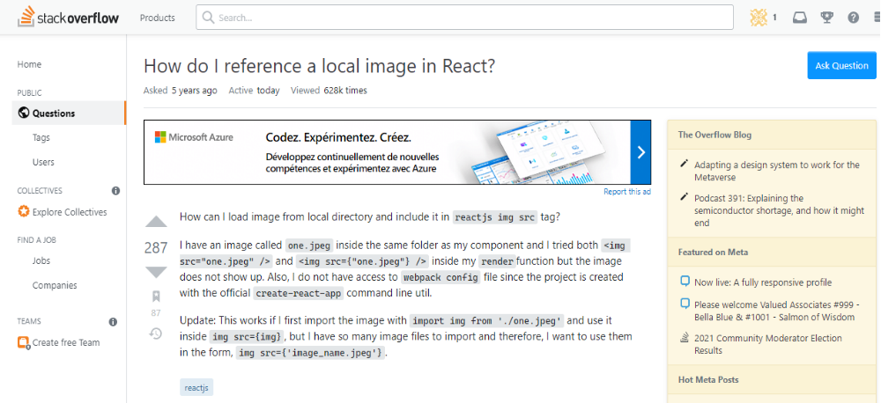
The question is regarding a user who cannot find the correct format for inserting an image to the React project.

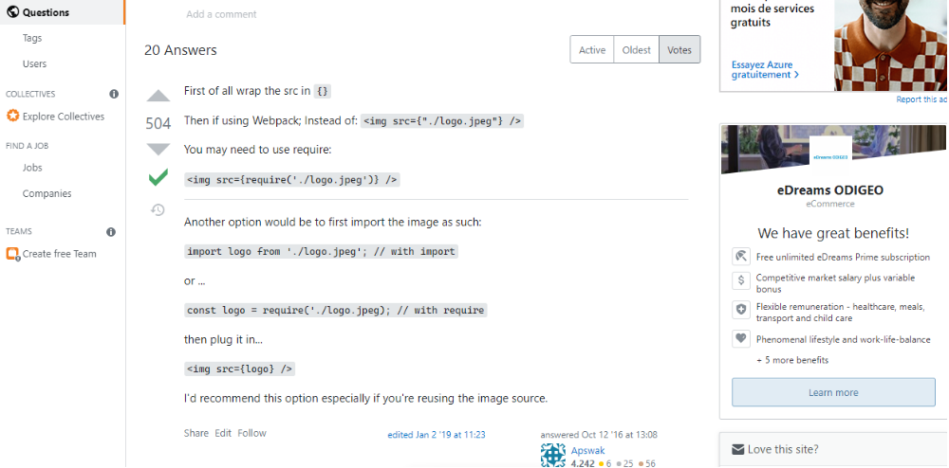
The answer reminds the user first of all to use curly brackets when displaying variables in the XML elements. He also explains options if webpack is installed. For me the option I used was the second one, in which the image is first imported into the React project and then inserted later on as a variable.

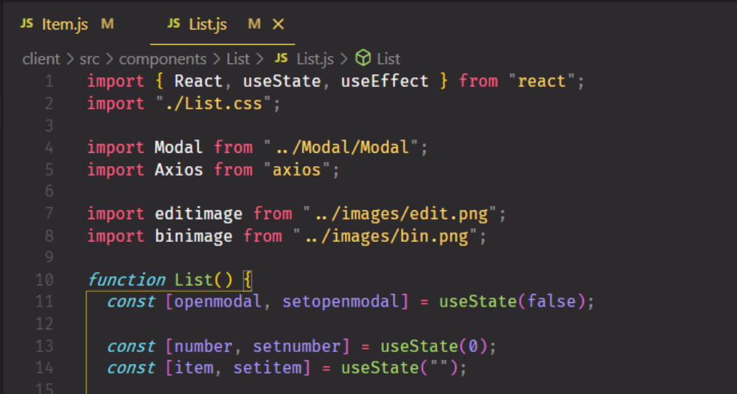

At the beginning of my List.js file I import both a bin image and an edit image, assigning them both variable names (line 7 and 8)

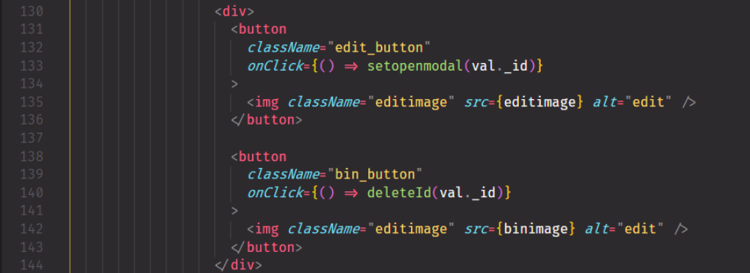

Later on I then insert these variables in the XML section of my code, to be rendered to the page.
We can see the editimage variable as the image source for the update button (line 135) and the binimage variable as the image source for the delete button(line 142)

Conclusion

